Tuesday 2nd December 2025
To:
Cllr Maggie Tyrrell, Liberal Democrat Leader of the Council
Cllr Ian Boulton, Labour Co-Leader of the Council

Hambrook Junction: Request for Transparency and Urgent Action

Dear Cllr Maggie Tyrrell and Cllr Ian Boulton,
On behalf of the communities surrounding the Hambrook Junction, I am writing to raise serious and ongoing concerns regarding the current traffic arrangements.
While we acknowledge the historical reasons for the changes implemented at the junction, residents are now facing unacceptable challenges undertaking daily tasks such as commuting to work, accessing education, attending medical appointments and shopping. These issues are not minor inconveniences. They are significantly impacting wellbeing and economic productivity across our area.
We understand that a report from the government’s Joint Air Quality Unit (JAQU), assessing the effectiveness of these changes, was scheduled for delivery to the Council in 2025. We request immediate confirmation of whether this report has been completed and insist that it be published without delay in the interest of transparency and public accountability.
Furthermore, if the Hambrook Junction now meets the required standards, the Council must act decisively. We urge you to:
1. Reinstate the right-hand turn at Hambrook Junction to restore essential connectivity
2. Conduct a comprehensive review of the ring road to address congestion and ensure resilience, particularly in light of the Local Plan’s proposal for 22,573 new homes
These actions cannot be deferred. Our communities deserve clear timelines and a commitment to solutions that keep pace with development. Failure to act will only exacerbate congestion, harm local businesses and diminish quality of life for thousands of residents.
We therefore request a formal response outlining:
- The status and publication date of the JAQU report
- A clear action plan and timeline for addressing these issues
On behalf of the whole Conservative Group, the relevant ward councillors and local residents, I look forward to your urgent reply and to working collaboratively to deliver the infrastructure improvements our communities need and deserve.

Yours sincerely,
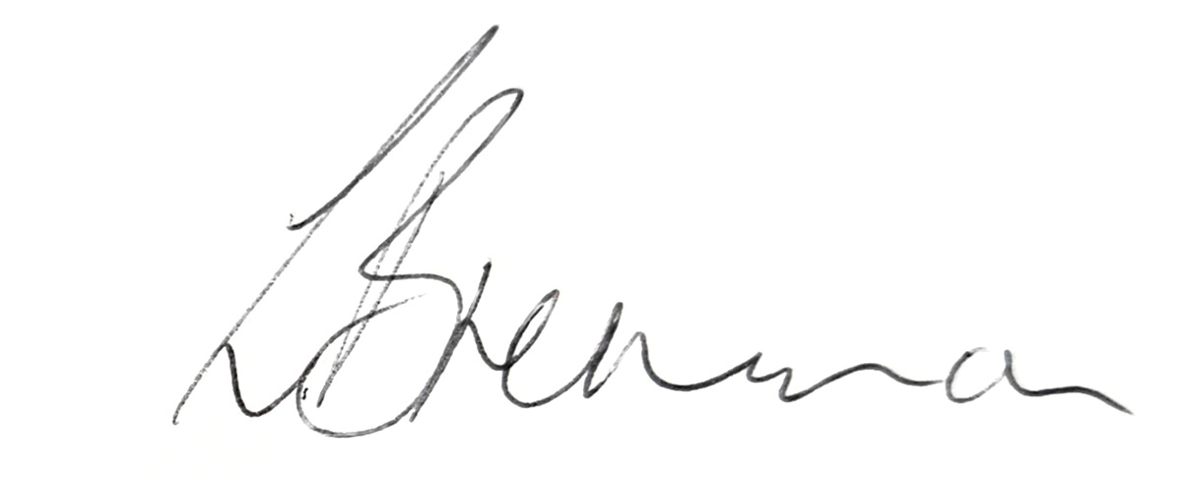
Cllr Liz Brennan
Leader of the South Gloucestershire Conservative Group

